**Introduction**

Welcome to the user documentation manual, this manual will go into details of all the pages and features of the website to get you to understand how to use and troubleshoot if you get stuff. Each page is split into sections related to the website. There will be pictures of example of the website pages with either arrows, wording, or both explaining what it does. At the end of the documentation, is an index where you can find the topic or go back to the table of contents to see the page number. Page numbers are located at the bottom of the pages.

**Purpose**

The purpose of the documentation is to help user like you, understand the website and also how to navigate through the website from all tabs and pages it offers. When a problem occurs, go to the section of the document to see the solution to that problem. The document is in full details of all pages and will always have pictures of screenshots of the pages and an explanation of that screenshot. We will also provide an example on how to do the inputs or explain how to do them.

**New Dispatcher First Sign In**

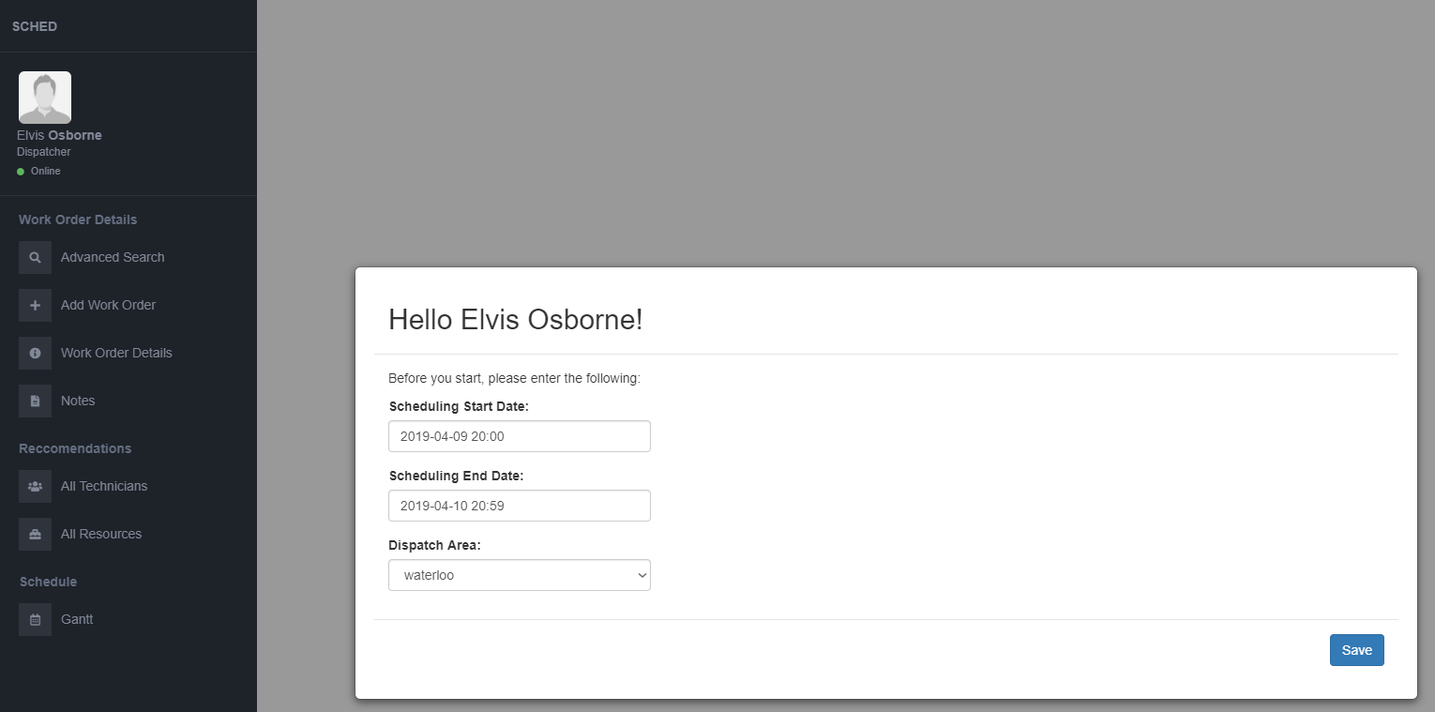

1

2

|  |
| --- |
| 1. Dispatch Information Fields 2. “Save” Button |

Fill in the Dispatch information fields(1) based on what time frame you would like to see jobs from and which area they are assigned to then press the Save button (2) located at the bottom of the form.

**Creating a work order**

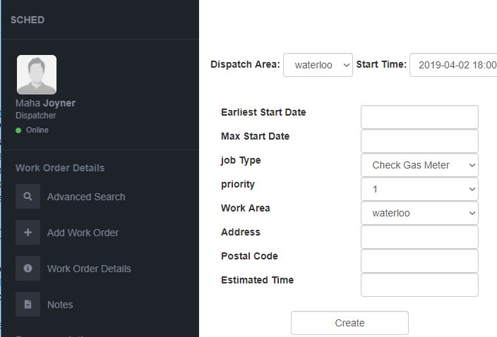

1

3

2

|  |
| --- |
| 1. “Add Work Order” Button 2. Work Order Information Fields 3. “Create” Button |

Click add work order button(1), this will then display a form asking for information on the new work order. Fill in all the fields(2). After verifying that all the information is correct click the create button(3) located at the bottom of the form.

**View work order details**

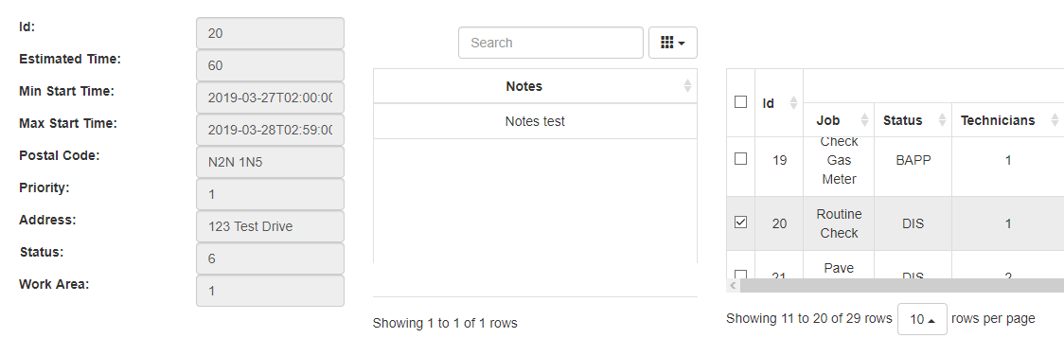

1

2

|  |
| --- |
| 1. “Work Order” Pane 2. Work Order Details |

3

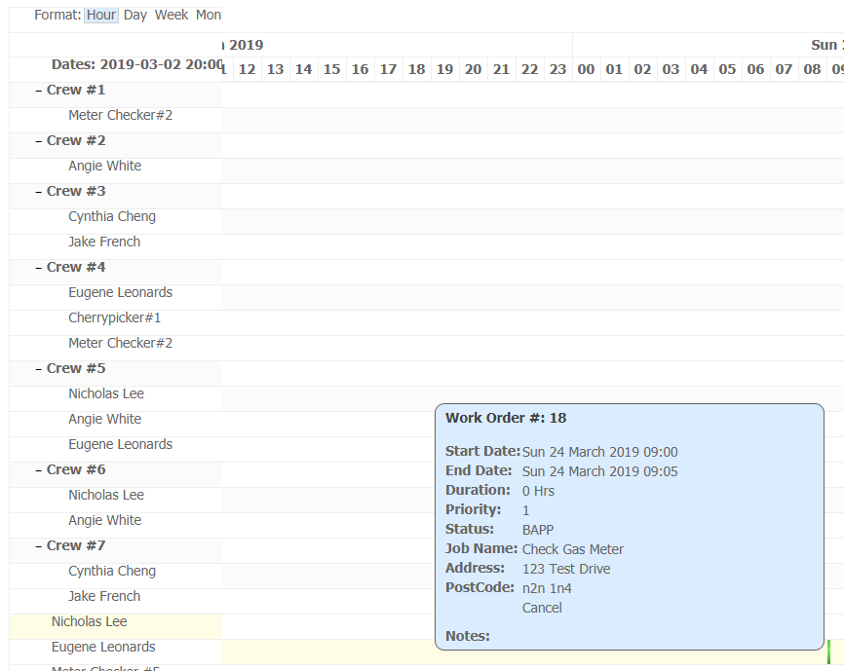

4

|  |
| --- |
| 1. “Work Order” Appointment 2. Work Order Details |

Click the desired work order in the work order pane(1). The work order details will be visible in a form to the left of the pane(2). You can also look at work order details(4) by hovering over an appointment(3).

**Updating a work order**

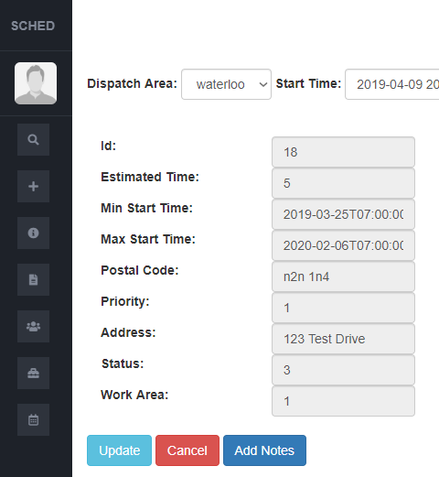

1

|  |
| --- |
| 1. “Update” Button |

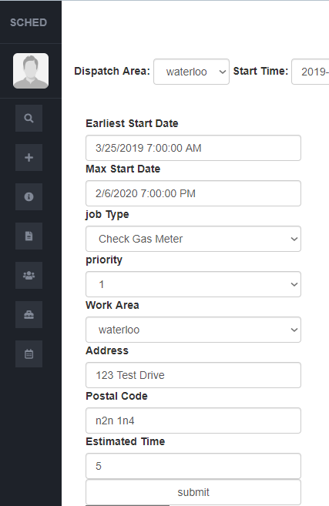

3

2

|  |
| --- |
| 1. “Work Order” Pane 2. Submit Button |

Click desired work order in work order pane(2). This will display the details in the work order form. Click the update button(3) found at the bottom of the form. Update desired details in the form and verify information is correct. Click the submit button and the changes will be saved.

**Canceling a work order**



1

|  |
| --- |
| 1. “Cancel” Button |

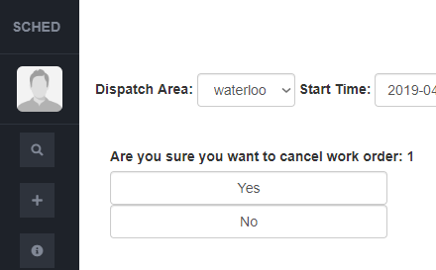

2

3

|  |
| --- |
| 1. “Yes” Button 2. “No” Button |

Click work order in work order pane. Click the cancel button(1) located at the bottom of the form. Click the Yes button (2) to confirm you would like to cancel the work order otherwise press the No button (3)

**Scheduling a Resource**

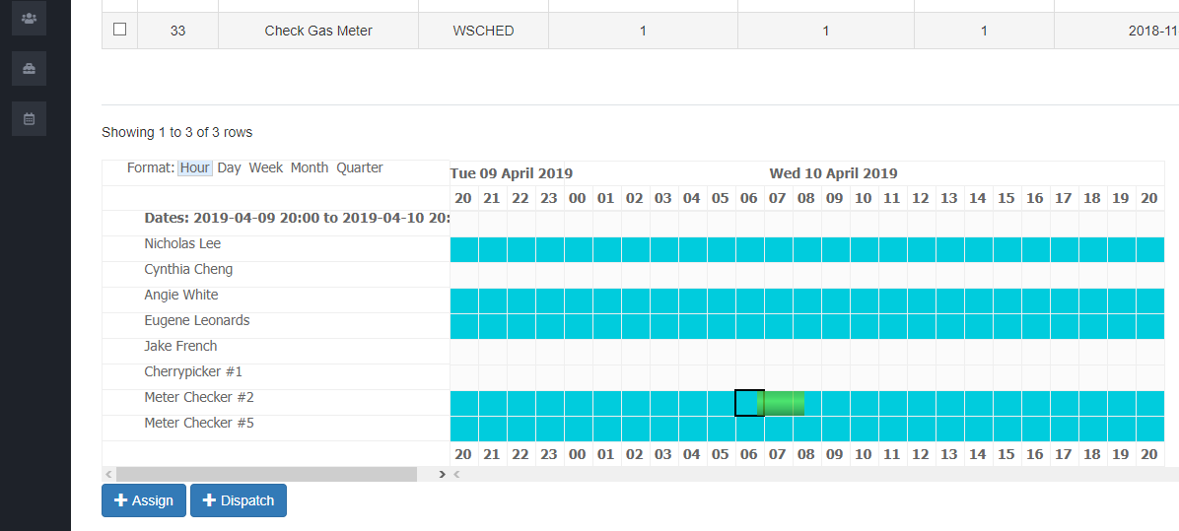

1

3

2

4

|  |
| --- |
| 1. “Work Order” Row 2. “Work Order” 3. “Resource” 4. “Time Slot” |

Drag work order row(1) onto desired resource in an open time slot(4). The time is labeled at the top of the chart and is displayed in the 24 hour clock. You can only drag a work order onto a resource(3) with blue rows as these are the resources qualified for the job. When scheduling a resource you can update the time they are assigned by dragging the appointment to a different time slot(4). If they time you drag it to is outside of the designated time the work order has to be completed in your change will be reverted. If there are other resources or technicians in the crew they will also have their appointments updated to match the new time.

**Scheduling a technician**

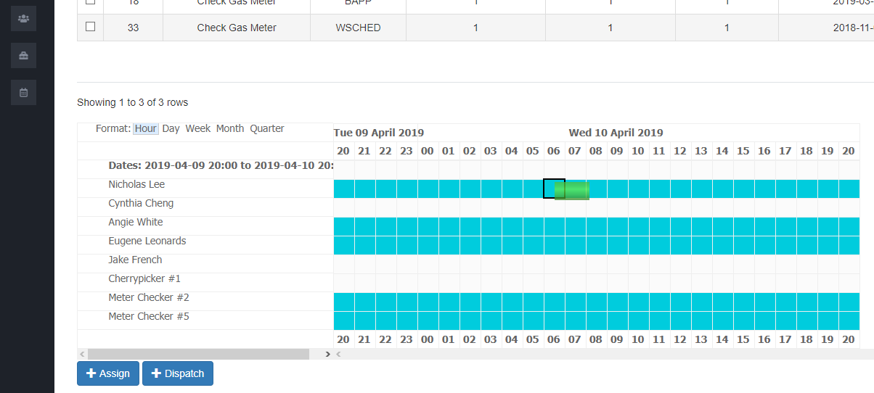

1

3

2

4

|  |
| --- |
| 1. “Work Order” Row 2. “Work Order” 3. “Technician” 4. “Time Slot” |

Drag work order row (1) onto desired technician in an open time slot(4). The time is labeled at the top of the chart and is displayed in the 24 hour clock. You can only drag a work order onto a technician(3) with blue rows as these are the technicians qualified for the job. When scheduling a technician you can update the time they are assigned by dragging the work order to a different time. If they time you drag it to is outside of the designated time the work order has to be completed in your change will be reverted. If there are other resources or technicians in the crew they will also have their appointments updated to match the new time.

**Assigning Technicians/Resources**

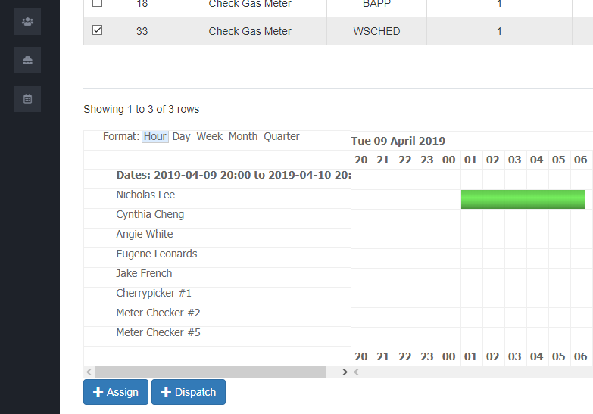

1

2

|  |
| --- |
| 1. “Work Order” Row Checkbox 2. “Assign” Button |

Once you have scheduled technicians and resources for work orders you can save your work without dispatching the work orders by ensuring all the work orders you want to save their work order row checkbox(1) checked and then pressing the assign button(2). This will try to save all your changes to the database, in the event of a conflict an error message will be displayed.

**Dispatching**



1

2

|  |
| --- |
| 1. “Work Order” Row Checkbox 2. “Dispatch” Button |

Check desired work order’s work order row checkbox(1) on the work order pane. Click the dispatch button(2) located below the gantt chart. This will try assign resources and technicians in the database so the database matches the gantt chart, if successful it will try to dispatch all work orders selected. This will try to dispatch all the work orders selected, if a work order does not have sufficient technicians or resources the system will display an error message and then move on to the next work order.